Reaksonet e adicionimit

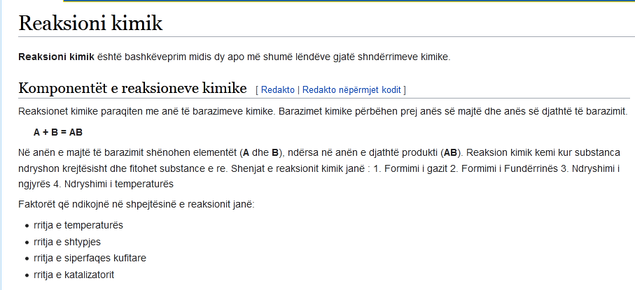
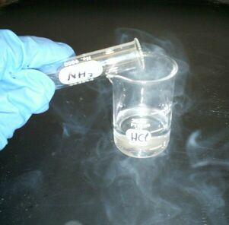
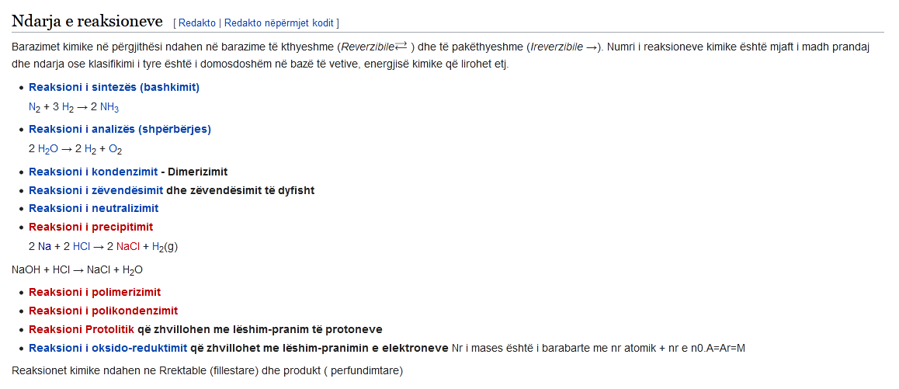

Ne youtube: Reaksionet e adicionit elektroil : https://www.youtube.com/watch?v=xT9VGmerG-0
Youtube: https://www.youtube.com/watch?v=_IW3t_Mij7E
Ne youtube : Reaksionet e zevendsimit : https://www.youtube.com/watch?v=NwWQ9N_H4zY
Reaksionet e zberthimit : https://www.youtube.com/watch?v=Bl1f9BCl6C4
Reaksionet e shtimit ose aderimit ne alkene : https://www.youtube.com/watch?v=B-Mw1cFJX6I

